Sams Kitchen www.samskitchen.net

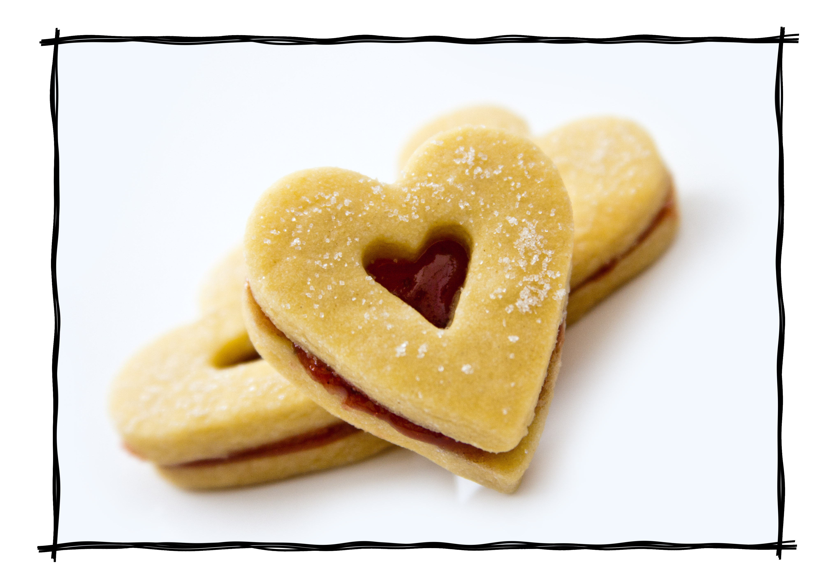
Jammie Dodgers

Ingredients
125g butter
55g caster sugar
180g plain flour
Jam of your choice

Preheat oven 190 C (fan 170 C)

Cream the butter and sugar together until light & fluffy. Sieve in the flour and mix well, bring together to form a ball of dough. Cover and place in the fridge for 30 minutes to chill.
Roll out on a well floured surface to about ½ cm thick. Use cutters, I used hearts & circles. If you have a smaller heart or circle cutter (or something else that will do the job!) use that to cut out on half the biscuits. They look great with a little ‘window’ so you can see the jam.
Place them on greased or lined baking sheets and bake for 10-15 minutes until cooked through & starting to turn a golden colour. Allow to cool on a rack. Spoon onto the complete half a generous helping of jam, then sandwich the window biscuit on top.
They are a bit oozy & sticky but delicious. We did find that the second day they’d stuck a little firmer, so less jam down the chin!

